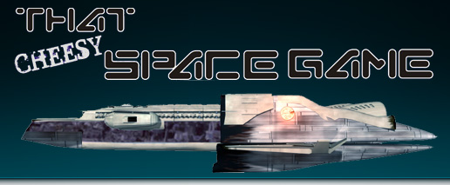
That Space Game

The Vergosi Race

The Vergosi are a saurian race with the morals and practices of corrupt 14th century Florentine merchants, or modern Arab and Japanese businessmen. The Vergosi appear to be the product of an evolutionary line similar to what would have occured had Earth's dinosaurs not been wiped out by a chance cometary collision. The Vergosi race is much older than the human, but reproduces slowly.
The Vergosi have had star travel since human prehistory, but they have only a handful of permanent colonies, preferring semi-permanent trade settlements instead.

It is probable that some enterprising Vergosi investor brought civilization to humankind. Ancient human Sanskrit bears a marked resemblance to Vergosi writing, and the oldest written human documents are contracts for wheat shipments.

Among the other races, the Vergosi are well known as traders, bargainers, shrewd business practitioners, and userers.

The Vergosi government is a balkanization, ruled by Corporations, and the powerful Vergosi Mafia. They are wealthy, not given to fighting, and act as brokers to the galaxy. Despite their inclination towards the bottom line, the Vergosi are proud, and can be very dangerous when cornered.

The re-discovery of the human race by the Vergosi in the mid 22nd century opened a new market for the race. The Vergosi were only slightly more technologically advanced than humankind, though they had possessed star travel for millennia.

The Vergosi were traders, with many useful things to sell to colony worlds, no longer being supplied by dysfunctional mother Earth. The Vergosi demanded high prices, and offered attractive credit terms. Because of their economic power, and the threat of the Vergosi Mafia, few humans dared either fight the Vergosi, or organize against them.

During the War against the Retull the Vergosi Mafia supported the Allied efforts to defeat the Retull, and even regulated the percentage of graft on arms and equipment sales to the UPC Fleet in order to speed the war effort. Vergosi traders offered discounts to the military, and agreed to a 1% per annum price increase until the war ended. The Vergosi even managed to form a Military. The Vergosi Armed Forces (VAF) isn't as well known as the Yorr Imperium or the UPC Fleet, but the VAF made up a great deal of the rear during the Retull Wars. Vergosi just aren't very useful as front-line warriors. Compared to humans and Yorr - Vergosi reflexes are fairly slow, though Vergosi are exceptionally tough. But Vergosi understand supply better than anyone.

The Vergosi do not teach "history" in schools, as there is no general agreement on "history" among the Vergosi. The Vergosi are racially incapable of distinguishing historical research from a Tax Audit or Discovery Action, and react with the same hostility toward both. Anyone prying too deeply into Vergosi history, which is essentially a welter of corporate and familial secrets dating back centuries, may find themselves "eliminated" by the Vergosi Mafia for "prying."

